Report for case study
On
Instrumentation II

For
“PURNA METAL CONCERN INDUSTRIES”
Patan Industrial Estate
Lagankhel, Lalitpur, Nepal
Tel: +977-1-5521407
Fax: +977-1-5528745



Submitted to:

DEPARTMENT OF COMPUTER AND ELECTRONICS ENGINEERING
KANTIPUR ENGINEERING COLLEGE

Submitted by:

Sahaj Shakya (2070/BEX/29)

16th February , 2016

ABSTRACT:

Studying is an complicated process and studying Engineering is much more challenging but interesting and practical. Theoretical studies in not sufficient for Engineering students. We being student in bachelor degree of electronics and communication engineering practical knowledge of our day today environment and society is very much essential. To fulfill this requirement we the third year student visited different industries of Patan Industrial Estate which was also included in our course of Instrumentation II called case study. This case study was very much helpful for we the engineering student to know the real application and use of engineering field for our society, nation and the whole world. For making this case study successful the important role goes to Purna Metal where we got chance to studied. We would like to thank Mr. Rupak Purna (supervisor) of the industry for allowing to study them and for his cooperative and friendly behavior .It was a large This is a large scale industry that manufactures different metal product like solar tuki, department store rake, servo panel, oven etc. After visit we made a report describing whole existing system , analyzing some problems and other things which are not so good to apply and gave an idea with corresponding design criteria in order to improve the current system by introducing automatic systems. In this way we completed a case study report.

Acknowledgement
For giving this wonderful opportunity we would like to thank the course maker of IOE, Pulchowk. Secondly we would like to thank our subject teacher Er. BRJ and to all the college family for giving us the permission for this case study. We again thankful to Mr.Rupak Purna (Supervisor) and his company for allowing us to report and study on his plant .His positive response towards our study and valuable information’s about the existing plant is so acknowledgeable. He helped us not only by giving his time but also by providing an opportunity to visit the corporation from where we could collect the knowledge of existing process and control system. We are very grateful towards the whole members of that company. We are also thankful to all our colleagues and teachers who gave us an idea and suggestion beside their busyness.

TABLE OF CONTENT:

Sn. | Title | Page no.
1. | Title page | 1
2. | Abstract | 2
3. | Acknowledgement | 3
4. | Table of Content | 4
5. | List of figures | 5
6. | Introduction | 6
7. | Methodology | 7
8. | Process and equipment used | 12
9. | Some final products | 13
9. | Basic block diagram of existing system | 14
10. | Proposed improvement to existing system | 14
11. | Operating principle | 15
12. | Cost estimation | 16
13. | Conclusion | 18
14. | Bibliography | 19

LIST OF FIGURES:
Sn. | Title | Page no.
1. | Purna Metals. | 6
2. | Domestic and imported raw materials | 7
3. | Heating furnish | 8
4. | CNC Router | 8
5. | Circular Saw | 8
6. | Drilling Machine | 9
7. | Power Machine (Punching) | 10
8. | Arc Welding | 11
9. | Assembling Process | 12
10. | Oven | 13
11. | 3-Phase Distribution Board | 13
12. | Department Store Rack | 13
13. | Solar Tuki(Lamp) | 13
14. | Server Rack | 13
15. | Servo | 13
16. | Basic block diagram of existing system | 14
17. | Proposed control system | 15

INTRODUCTION:
We have visited to Purna Metal Concern Industries (Patan Industrial Estate) for the case study. As the market value for the metal products has reached peaks, general public are looking for the product that lasts longer, of high quality and that are reasonable in cost. After the establishment of Purna Metal Concern Industries in 2043 B.S. (1986-87 A.D.), they have devoted themselves in producing metal products like Voltguard boxes, UPS casings, Electrical Pannel Boards, Distribution Boards, Voltage stabilizers, Trunking, Cable trays, 19" Standard Racks and other kind of Steel and Stainless steel products without compromising in the quality. They have been serving general public, small industries which are involved in manufacturing above mentioned products as well as large government projects which are serving for the upliftment of the living standards. This industry is well known for the manufacturing of customized metal products as per the need of customer.
It uses the basic raw materials as iron, steel aluminum and other metals imported from different areas of Nepal and neighbor countries like India , China ,and Bangladesh With the increasing demands of metal items in day today market ,industry is continuously upgrading the amount of production at affordable price. It is one of the largest and oldest metal industry that used skilled manpower. The manpower used are specially trained Nepalese people had been trained from India. Different imported machines are integrated so as to form a complete control system for the industry. Apart from enhancing the national assets it is equally minimizing the unemployment problem too.The main purpose of this case study was to learn the process of existing system,find any problems and aid some microprocessor based control mechanisms for better performance of the system and its production in an efficient and economically.

Methodology:
Different process with corresponding machine details are given which we have studied on the occasion of case study. They are as below:
RAW MATERIALS:
Mostly iron is the raw material for this company however all kinds of metals like aluminium, copper, etc are also imported according to the order.
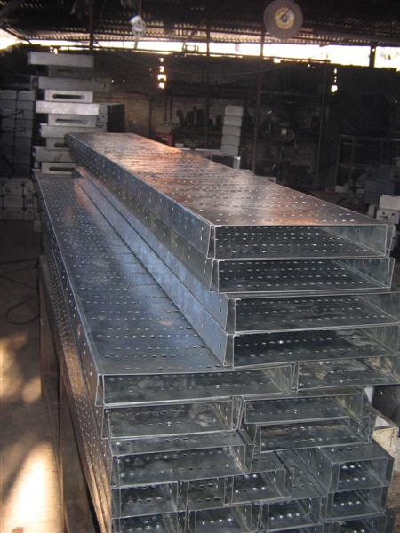
Fig (i): Raw Material.
Occurrence and Uses:
Iron is a chemical element with the symbol Fe (from Latin: ferrum) and atomic number 26. It is a metal in the first transition series. It by mass is the most common element on Earth, forming much of Earth's outer and inner core. It is the fourth most common element in the Earth's crust Iron is the sixth most abundant element in the Universe and the most common refractory element. Iron is a metallic element that is very common in our planet. It has many uses in different industries and even in the human body. Iron is a strong metal that is not that expensive. It is fairly cheap that’ why it is commonly used in manufacturing machine tools, automobiles, hulls of large ships, machine parts, and even building parts. A good chunk of structures today are made of metallic iron.Iron is also common in many different tools, surgical equipments, and appliances. Stainless steel is a common type of steel used in a host of different products. It is created when iron is combined with other metals. It is 100% recyclable and is used in aircrafts and automobiles. The use of stainless steel and iron in this form makes every thing in our world today working perfectly fine

Properties Table
Group | 8 | Melting point | 1538 ºC, 2800.4 ºF, 1811.15 K
Period | 4 | Boiling point | 2861 ºC, 5181.8 ºF, 3134.15 K
Block | d | Density (kg m⁻³) | 7873
Atomic number | 26 | Relative atomic mass | 55.845
State at room temperature | Solid | Key isotopes | ⁵⁶Fe
Electron configuration | [Ar] 3d⁶4s² | CAS number | 7439-89-6
ChemSpider ID | 22368 | ChemSpider is a free chemical structure database
Process and Equipment Used:
The major components of the existing system with their full description and working methods are as below:
- Melting Metals:
The main work performed by vatti(oven) is to produce tremendous amount of heat by firing. The main source of fire is electricity.After firing, the huge amount of heat produces. The raw materials are then kept on furnace so that they can be melted. The metals melted at its melting temperature of approx.660º-1000c the melted metals then are molded to required shape and size in fixed container.

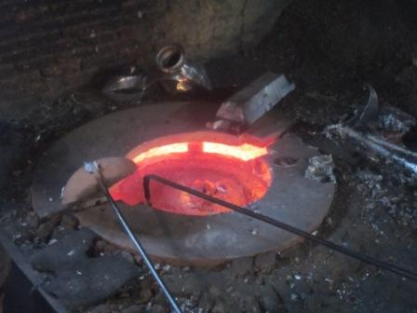
Fig (ii): Furnace (Metals melting)
2) Cutting Plates:
The raw material after melting gives the shape as required. Then the metals are cut into required shape and size according to the product to be made. For this process different metals cutting machines like Metal Cutting Saw, CNC Router, Electric Metal Cutting Circular Saw etc. This all machines had been imported from India. Almost all of them are of latest version but are manually controlled.

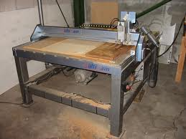


Fig (iv): Circular Saw

Fig (iii) :CNC Router

Drilling Metals:

Different metal cut pieces are drilled in the required position accordingly to the product. For this propose different drilling machine had been used of different diameter like ½ inch, ¼ inch, 1 inch etc.

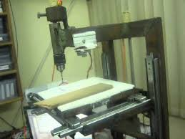

Fig (v) : Drilling Machine .

Punching:

Metal have been punched for different propose with punching machine called Power Machine. Holes of different diameter such as ¼, ½, 1 inch have been punched by using this machine. This kind of holes are used for casing, switch box, etc.

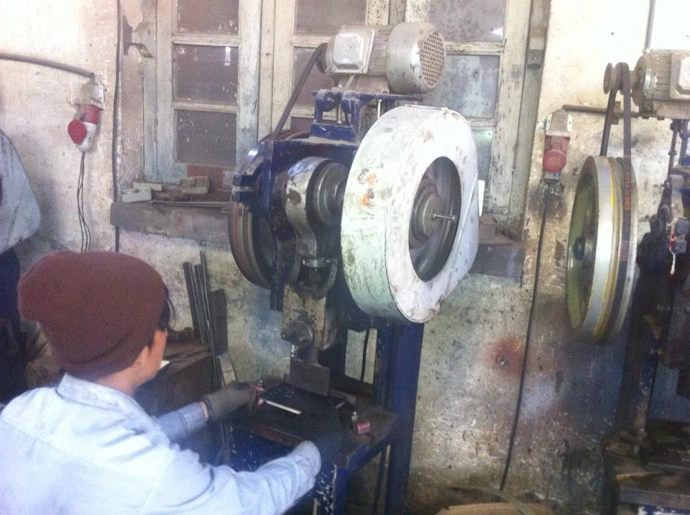

Fig (vi): Power Machine (Punching)

Welding:

Welding is a fabrication or sculptural process that joins materials, usually metals or thermoplastics, by causing coalescence. This is often done by melting the work pieces and adding a filler material to form a pool of molten material (the weld pool) that cools to become a strong joint, with pressure sometimes used in conjunction with heat, or by itself, to produce the weld. This is in contrast with soldering and brazing, which involve melting a lower-melting-point material between the work pieces to form a bond between them, without melting the work pieces. After punching the metal pieces are joined together by this process. Mainly two method of welding had been followed. i.e Gas Welding and Arc Welding.

i) Gas Welding:

The most common gas welding process also used in this industry is oxy fuel welding also known as oxyacetylene welding. It is one of the oldest and most versatile welding processes, but in recent years it has become less popular in industrial applications. It is still widely used for welding pipes and tubes, as well as repair work. The equipment is relatively inexpensive and simple, generally employing the combustion of acetylene in oxygen to produce a welding flame temperature of about 3100 °C. The flame, since it is less concentrated than an electric arc, causes slower weld cooling, which can lead to greater residual stresses and weld distortion, though it eases the welding of high alloy steels. A similar process, generally called oxy fuel cutting, is used to cut metals.

ii) Arc Welding:

Second process used for welding was Arc Welding.These processes use a welding power supply to create and maintain an electric arc between an electrode and the base material to melt metals at the welding point. They can use either direct (DC) or alternating (AC) current, and consumable or non-consumable electrodes. The welding region is sometimes protected by some type of inert or semi-inert gas, known as a shielding gas, and filler material is sometimes used as well.

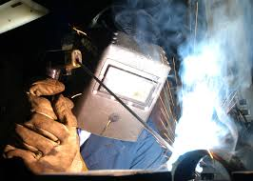
Fig (vii): Arc Welding.

- Assembling Process:

All the cut metal who have drilled and punched in required position are finally assembled to final product. This process is also carried out in different phase. At first fitting the small metal pieces have been done. After than they are tighten with different nuts and bolts, nails, screw etc. Thus all the fitted product finally gives ready to the final product.
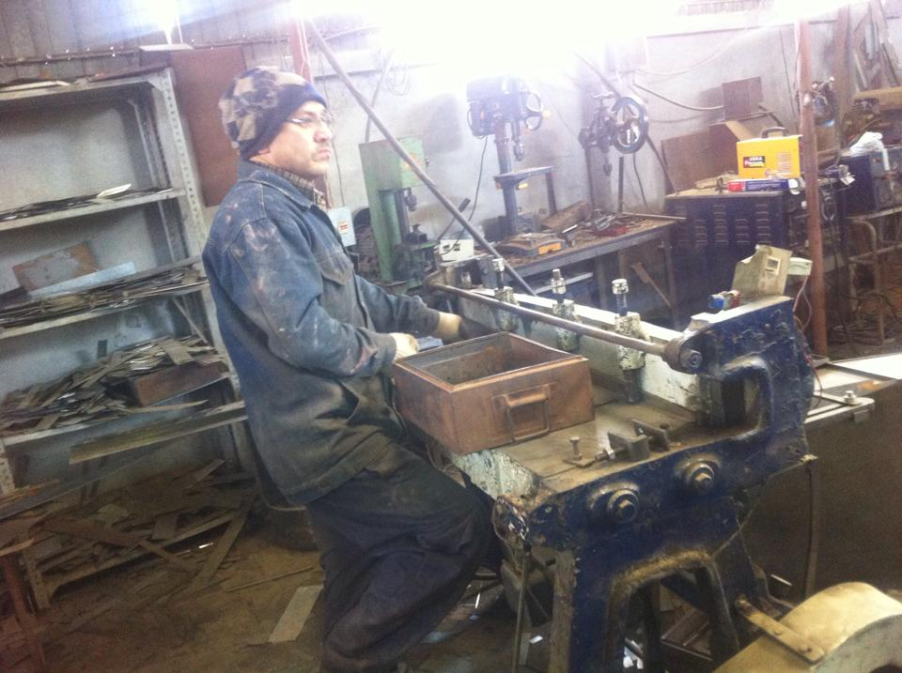
Fig (vii): Assembling Process

- Painting and Finishing:

Painting is the practice of applying paint, pigment, color or other medium to a surface (support base). The medium is commonly applied to the base with a brush but other implements, such as knives, sponges, and airbrushes, can be used. Paintings may have for their support such surfaces as walls, paper, canvas, wood, glass, lacquer, clay, leaf, copper or concrete, and may incorporate multiple other materials including sand, clay, paper, gold leaf as well as objects.This is the final touch to the product. It also contains fitting extra useful equipments on the final product like lock, handle, and other necessary items.

Some of the final products

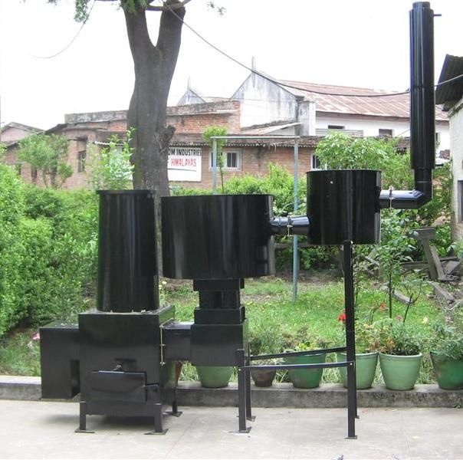
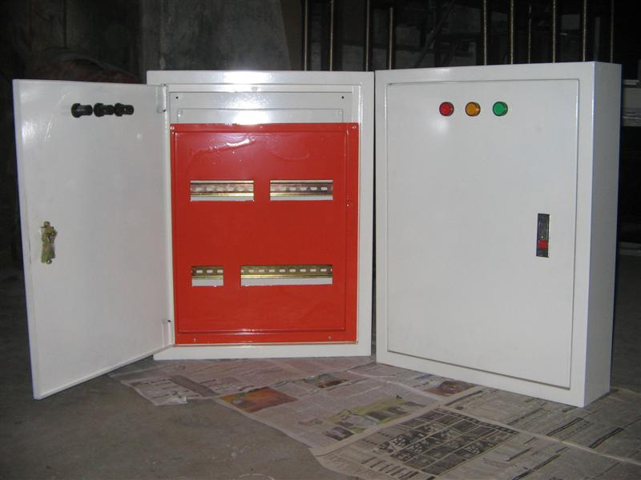
Fig (viii): Oven Fig (ix): 3 phase Distribution board

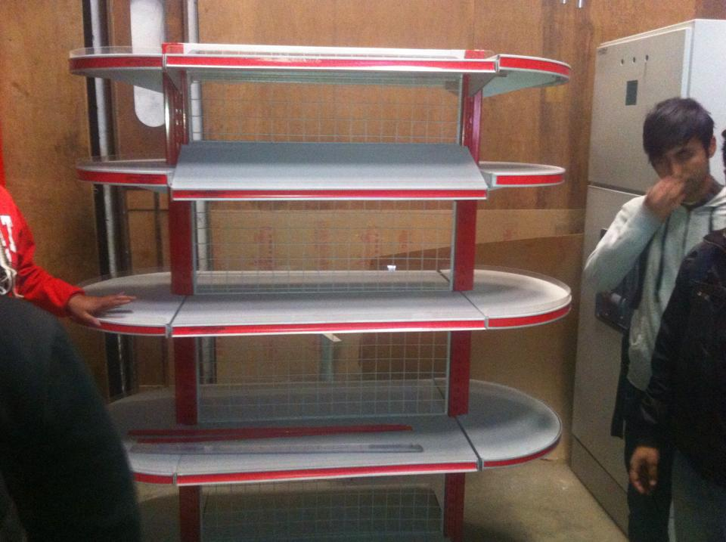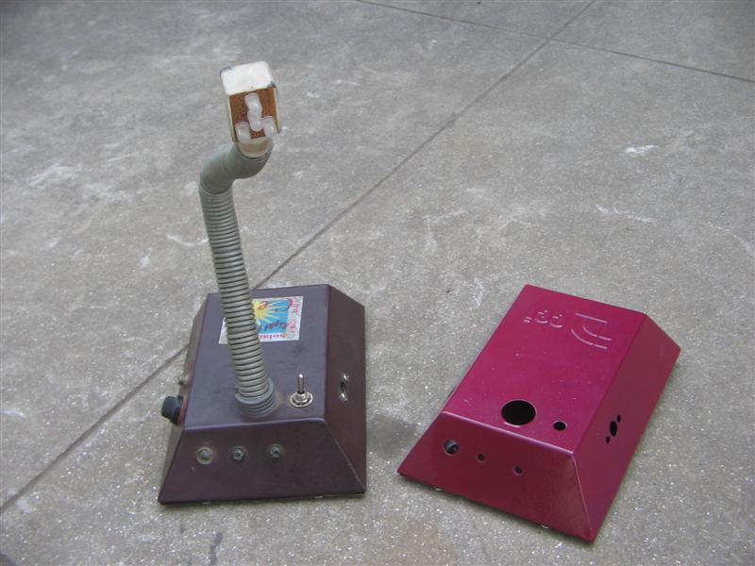
Fig (x): Department Store Rake Fig (xi): Solar Tuki(Lamp)
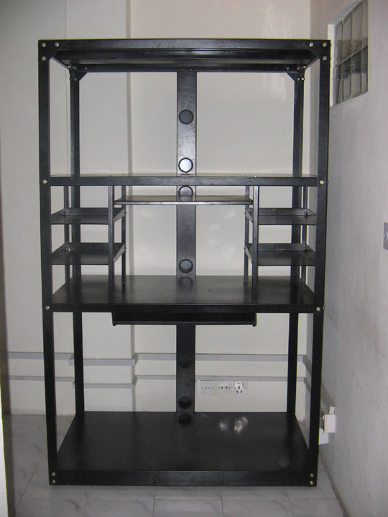
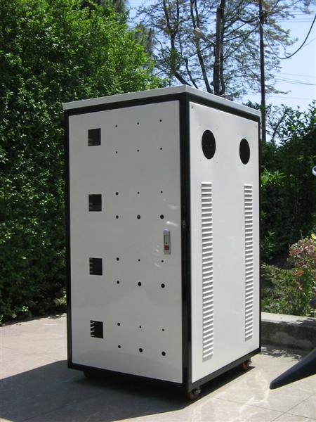
Fig(xiii):Servo
Fig (xii): Server Rack

BASIC BLOCKDIAGRAM OF EXISTING SYSTEM:

RAW METALS
CUTTING PLATES
DRILLING METALS

WELDING
ASSEMBLING
PUNCHING

FINAL PRODUCTS
PAINTING

Fig: Block diagram of existing system.

Proposed Improvements to The Existing System:

Sheet Metal Laser Cutter
Kern's laser systems can be equipped in replace of traditional system with new technology which allows for the successful cutting of light gauge sheet metal. It commonly cut metals include stainless steel, mild steel and aluminum. The Automatic Focusing Height Follower developed by Kern Laser Systems is one of the key elements to successful metal cutting. An automatic sensor senses the capacitance from the tip of the isolated cutting nozzle to the metal being cut. High pressure gas assist is injected into the optics assembly which allows the sheet metal to be pierced and results in a clean and smooth cut. A durable steel cutting bed is easily installed in sections. This specially designed cutting bed reduces the amount of surface contact with the metal being cut.
This is purely an computerized process and have many advantages over previous old and traditional method like: (i) Clean and smooth cut. (ii) Low operating cost. (iii) Intricate cutting.

Block diagram for control system:
Temp.
Sensor
Amplifier
Analog to Digital
Converter

Temp.display
(Seven seg.)

MICROCONTROLLER
M1
M3
Oven
Feedback

M2
Punching
Machine
Drilling Machine

Fig: Block diagram of proposed control system.
Operation principle:
After the raw materials are kept in the furnace, plant is switched on. At starting of process microcontroller compares the furnace with desired temperature. The temperature of furnace at start is low so that microcontroller starts the motor which automatically opens the electric flow of current. This starts electric oven to ignites and starts heating the metals. The temperature of furnace is regularly sensed by the sensor and outputs electrical signal. The signal is then amplified by an amplifier in order to enable rest of the system. The output analog signal from amplifier is then converted into digital signal by Analog to Digital Converter. The output from ADC is processed and analyzed by the microcontroller. A seven segment display connected parallel port of microcontroller displays regular temperature of furnace. This temperature is now compared with desired temperature of 800°c which is already set to microcontroller.
When temperature of furnace reaches to desired value, microcontroller sends three control signals to each of the three motors M1, M2 and M3. Motor M1 controls regulation of electricity so that constant amount of current flows, which keeps temperature of the furnace constant at 800°C. Motor M2 rotates the gear of punching machine. Time delay is maintained between the rotation of gear of punching machine by motors M2. Motor M3 rotates the wheel of drilling machine. All the processing time is set on microcontroller .Every process is done step by step once at a time in a cyclic order Process like melting, pouring, cutting, drilling and punching is done by microcontroller controlled system. When set time is complete microcontroller switches off all the motors.
Cost estimation:

Present existing System
S.N | Title | No. | Charge | Total
1 | Manpower | 12 | 500*26days | Rs.1,56,000
2 | Raw material | 2500 kg/month | Rs.50/kg | Rs.1,25,000
3 | Electricity | Per month | Rs. 20,000 | Rs. 20,000
4 | Repair and maintenances | Per month | Rs. 20,000 | Rs. 20,000
5 | Miscellaneous | - | - | Rs.40,000
 |  |  | Total | Rs.3,61,000

Total cost per month= Rs.3,61,000
Total amount of raw material used per month= 2500kg
Total production cost per kg=Rs.145

Proposed System:
Sn. | Title | No. | Charge | Total
1 | Manpower | 5 | 500*26 | Rs.65,000
2 | Raw material | 2500 kg/ month | Rs 50/kg | Rs.1,25,000
3 | Electricity | Per month | Rs 50,000 | Rs 50,000
4 | Repair and maintenance | Once a month | Rs 20,000 | Rs 20,000
5 | Miscellaneous | - | - | Rs.40,000
 |  |  | Total | Rs.3,00,000

Total cost per month=Rs.3,00,000
Total amount of raw materials used per month=2500kg
Total production cost per kg=Rs.120

Profit / Loss analysis:

From above cost estimation, comparing both systems we observe that:
The total cost per kg in existing system = Rs. 145.
The total cost per kg in improved system = Rs. 120
Total profit per kg=Rs. (145-120) = Rs. 25
Total Production in a month=2500kg
Total profit per year=2500*25 *12=Rs.7,50,000
Initial cost for proposed system (Approx.) =Rs.15, 00,000
Analyzing above data the initial investment in the proposed system could be recovered in about two years.

Conclusion:

This case study helped us in various ways. The main aim of this case study is to analyze, study, and describe the existing plants, understand it and do best from our side in order to enhance the existing capability in a precise way by introducing microprocessor based instrumentation system which leads to proper automatization of the plant. In addition we concluded this project gaining the experience of group study, combinational study etc.
After whole descriptive analysis on our case study on “Metal Workshop” we came to conclude that the existing system could be made far better in course of production rates and in economical point of view. This can be done by introducing certain electronics and electrical instruments that we have studied theoretically. For doing so, we firstly found out some blocks of plants that can be automated and well managed. After this we recommended automatic electric controller oven by introducing instruments like sensors, comparators, controllers etc. As a course of simplicity and economy we recommended a electric oven in place wood oven (which produces more smoke).In overall improved system reduces the no of workers required and amount of fuel is also reduced in comparison to existing system. On applying the recommended system the initial cost may be high but in overall calculation we are assure that this will lead the company to great success by near future.

Bibliography:

To complete this case study report we have taken following references:
WWW.google.com.
Microprocessor and interfacing (second edition)
- By Douglas V. Hall

